BrandPush Revolutionizes Press Release Distribution, Empowering Businesses to Make a Powerful Impact

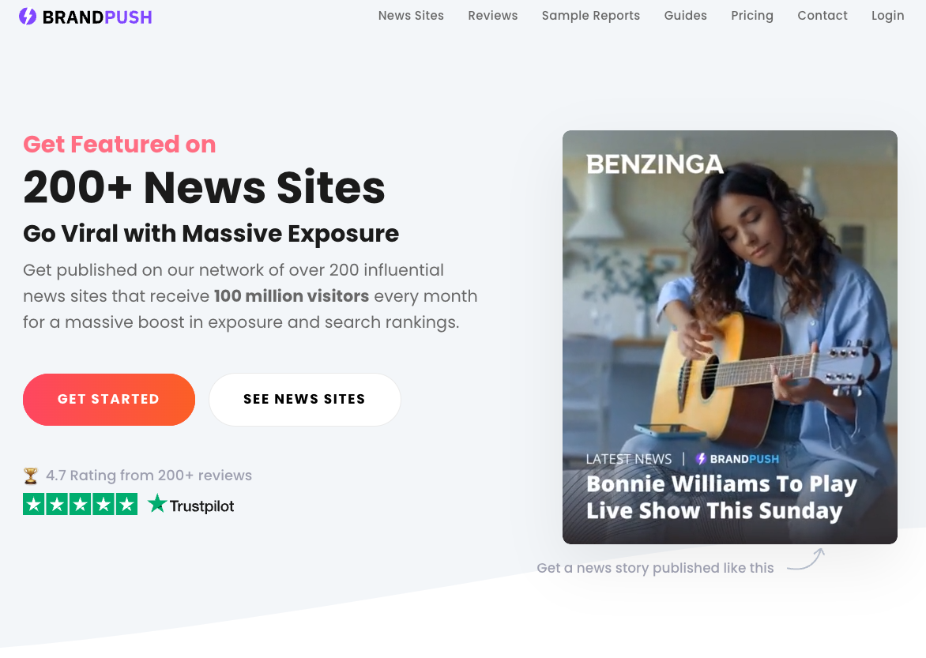

BrandPush has quickly positioned itself as a force to be reckoned with in the world of press release distribution, transforming how businesses obtain exposure and develop brand presence. With a commitment to delivering outstanding press release distribution services, BrandPush enables companies of all sizes to make a powerful impact through their news announcements.

A press release is a strategic communication strategy that enables businesses to share vital news or information with the general audience. Businesses may generate enthusiasm about new products, partnerships, or other significant developments by creating an excellent press release. The primary goal is to acquire immediate exposure, gain the trust of existing and new customers, and drive more traffic to websites or physical stores.

What truly sets BrandPush apart is its creative approach to broadcasting brands' messages and stories. The organization boasts an impressive track record of gaining significant exposure in as little as seven days, resulting in exceptional client growth. Their team of skilled professionals excels at crafting compelling press releases that consistently secure placements on the first page of Google, significantly enhancing online visibility and attracting more organic traffic. The press releases are published on reputable news sites, and search engines recognize these backlinks as high authority recommendations.

Notably, BrandPush ensures the publication of their clients' press releases on over 200 significant news sites with a combined monthly audience of 100 million. These strategic partnerships with major platforms such as CBS, FOX, NBC, USA Today, and more ensure that the clients' messages reach the right target audience, maximizing the impact of their news announcements.

The tangible results achieved by BrandPush have earned them glowing reviews, with an average rating of 4.7 on Trust Point. Thousands of satisfied clients from around the world have shared their success stories. Samantha Lopez expressed her delight with the service, saying, "I am thrilled with the service. BrandPush was responsive and easy to work with. They said they would distribute our press release to over 200 media outlets, and we got 246! The 'as seen on' badge looks great on my site. Moreover, their Google News articles gave us an unexpected SEO boost."

Jan Howell also provided positive feedback: "It took them nine days to write and distribute my press release. They got it on all the websites they listed. It appears they do exactly as they claim. I will be ordering press releases from BrandPush every month."

In addition to amplifying brand exposure through press release distribution, BrandPush offers an exclusive customizable "As Seen On" trust badge that businesses can display on their websites. This badge has been proven to increase conversion rates by up to 48%, instilling trust and legitimacy among online visitors. Furthermore, clients leverage their published articles to get verified on various social media platforms, including Instagram, Facebook, Twitter, and more.

BrandPush provides two compelling distribution options for its clients. The Popular News Network comprises significant news sites and is suitable for most cases, although certain topics may not be eligible. Meanwhile, the Alternative News Network accepts nearly all topics, making it an ideal choice for subjects like cryptocurrencies and supplements.

"We are the ultimate choice for press release distribution, with a proven track record and years of experience. Our highly qualified team will elevate your brand's exposure by crafting and publishing an award-winning story," remarked a BrandPush spokesperson.

Utilizing Brand Push's writing and publishing services is straightforward. Clients can fill out a sign-up form on the company's website, and within 5-7 days, their press release will be live on more than 200 reputable news websites, sparking newfound interest and growth for their business.

For more information and pricing details, please visit the official BrandPush website at www.brandpush.co.

Contact Details:
Business: Brand Push
Contact Name: Trevor
Contact Email: hello@brandpush.co
Website: www.brandpush.co
Country: United States

