Unlock the Power of Targeted Traffic with Simple Traffic, a Revolutionary Visitor-Forwarding Platform that Redirects Quality Traffic to Client Websites
More traffic, better online visibility, organic leads, and ultimately increased revenue and profitability.
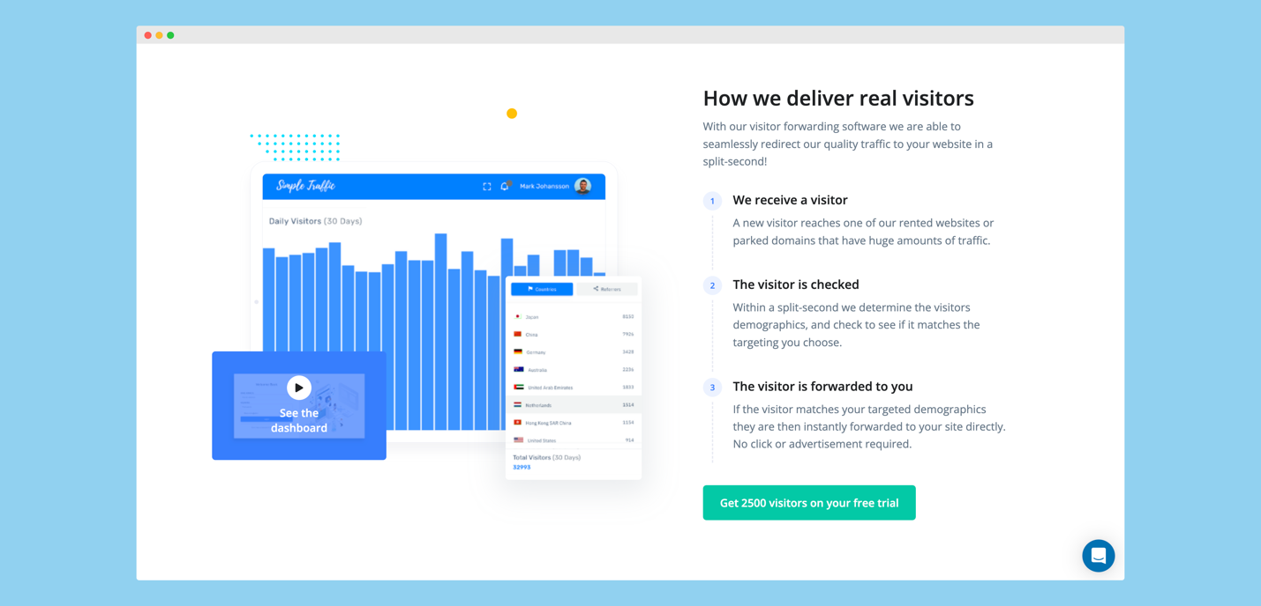
Creating a strong online presence is the key to business success in the digital era. Therefore, businesses and individuals are in a heated race to attract audiences to their websites to secure their place in the business environment. Fortunately, billions of people are online daily, meaning the target customers are most likely online. Unfortunately, attracting the right audience to drive meaningful results is rather tricky. Simple Traffic, a leading-edge targeted traffic generation platform, ushers in a new era of visitor forwarding with its groundbreaking software that seamlessly redirects quality traffic to websites in seconds.
Real visitors drive real results.
As reliance on the digital landscape grows, Simple Traffic offers a simple, straightforward, and reliable solution for businesses and individuals seeking to amplify their online presence and generate high-quality leads from real, targeted website visitors. Through a revolutionary approach that streamlines the process of driving traffic to online platforms, Simple Traffic, unlike traditional traffic generation, doesn’t rely on bots and complicated campaigns. Instead, the platform leverages its high amount of real traffic on its domain network to deliver genuine human traffic to client websites.
Understanding that driving traffic is only one step in a long journey to lead generation and conversion, Simple Traffic offers comprehensive services, including precision targeting, enhanced analytics, round-the-clock support, and scalable plans, to ensure clients receive website visitors that have an interest in their products, services or content. From its extensive network of websites and domains, Simple Traffic matches the visitors with the client’s targeting, and if they qualify, they are instantly forwarded to the website. Customizable targeting on the platform allows clients to specify their demographic preferences. “We only forward you visitors from the countries, devices, and internet browsers you choose.”
Most importantly, Simple Traffic helps businesses optimize website speeds by offering helpful insights and tracking. Clients can see where their web visitors are coming from on the dashboard, which helps understand visitor behavior, track bounce rates, and more for informed growth strategies.
Real visitors’ subscriptions
Starting with a free trial that grants clients 2500 website visitors, Simple Traffic has designed scalable subscription plans to help businesses and individuals achieve their traffic goals. With the free trial, clients get 500 visitors on any subscription plan for the first five days. After the trial period, Simple Traffic offers various monthly subscription plans tailored to the needs of businesses of all sizes.
The Simple Traffic difference
Simple Traffic is designed to provide an effective and hassle-free way to generate real, qualified website traffic for businesses in the digital space. By delivering relevant traffic through targeting, the platform propels businesses to success with increased leads and conversions. This approach has established Simple Traffic as a game-changer in targeted traffic generation and visitor forwarding.
With its trailblazing software, Simple Traffic has become a powerful platform recognized as an industry leader. Visit https://learn.simpletraffic.co/ to learn more.
Contact Details:
Business: Simple Traffic
Contact Name: Trevor
Contact Email: hello@simpletraffic.co
Country: United States
Website: www.simpletraffic.co

