Simple Traffic is Proving to Be the Solution for Genuine, High-Quality Traffic by Unleashing the Power of Genuine Engagement
Simple Traffic offers a unique solution in the field of digital marketing, which is known for changing and growing all the time. It starts with a tempting deal of 2,500 free visitors for a five-day trial session. It gives the business owner a special chance to see the benefits of the service in real time, which is an appealing experience for the wise business owner.
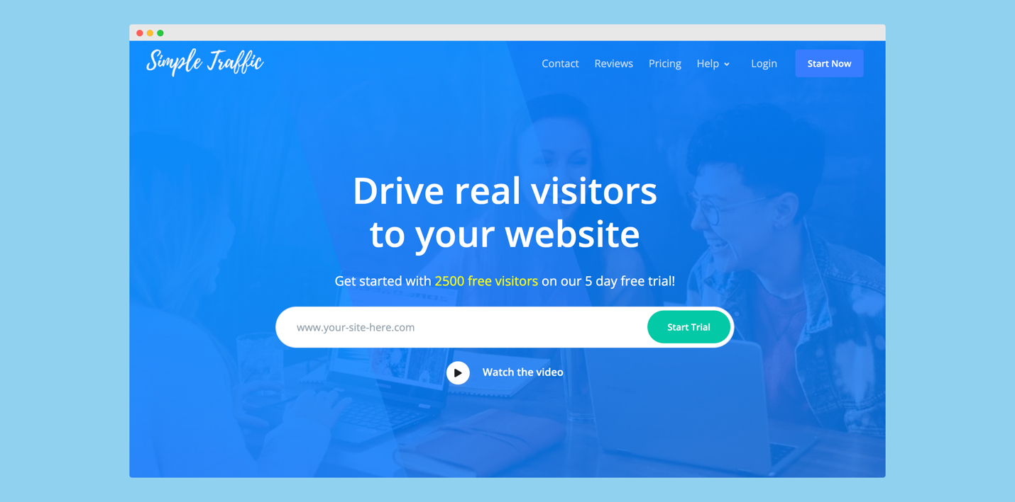
Simple Traffic provides high-quality traffic specifically tailored to their client's needs; doing so increases connection and sales. One of the most important benefits that Simple Traffic has over its competitors is the quality of the traffic it sells. Every person they refer to a website is real, meaning they're potential customers who look around and interact with the site by clicking links. There is a real chance they will buy something, sign up, or become a lead. It's a big step up from using bots or fake guests, which often inflated statistics without adding real value to the business.
Using their service could also help businesses to move up in the search engine results, which is another important benefit. They know how to use Google and other search engines to increase a website's ranking by showing that the page is getting real Traffic. This change in search rankings can have a multiplicative effect on the website's organic traffic over time, making it more visible and improving its image.
Additionally, they help to improve statistics. Google Analytics makes it easy to keep track of the traffic that Simple Traffic sends, which makes it possible to get a more accurate measure of success and figure out where changes need to be made. Having access to this important information can make all the difference in a marketing plan. It is worth mentioning that Simple Traffic has improved targeting. They ensure that a very targeted approach gets the right kind of traffic by focusing on the chosen countries, devices, and internet browsers. This painstaking process is included in all of their plans at no extra cost, which makes them even better deals.
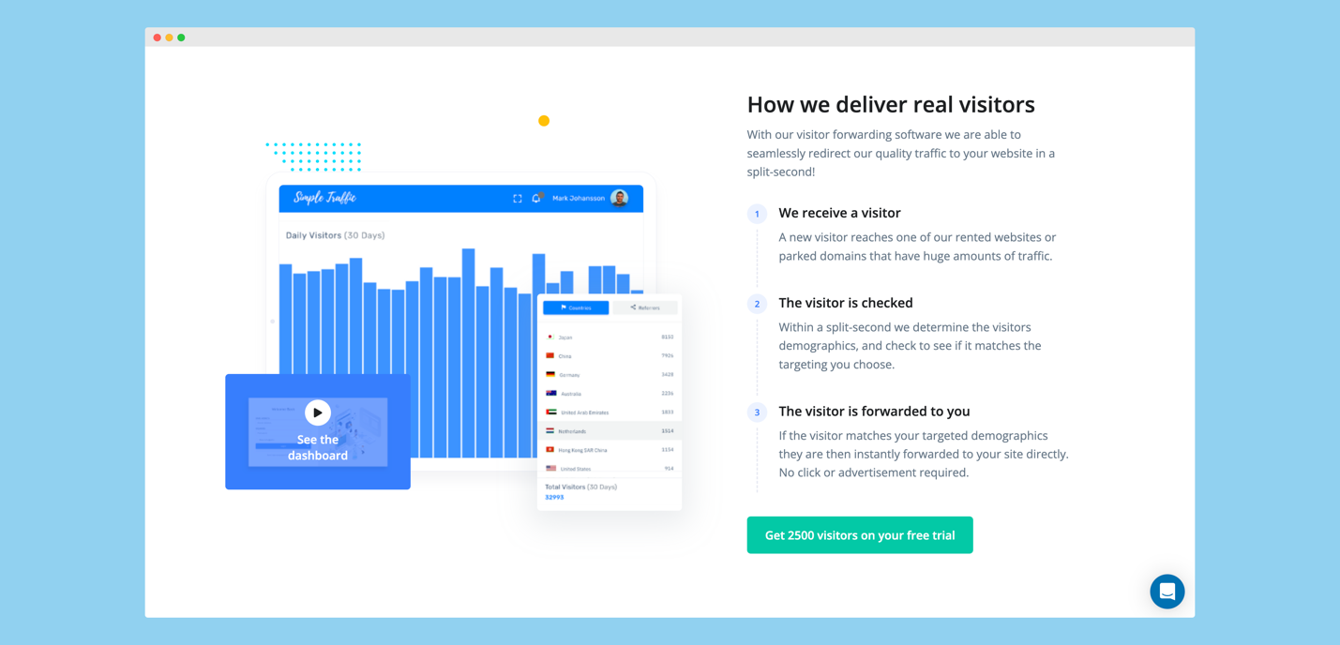
Simple Traffic gives essential information and tracking tools to improve the experience of using the product. Through the easy-to-use screen, clients can keep track of the people going to their website and know exactly where the traffic is coming from. Using this important information as a guide will help the website work better, making it faster and more efficient.
Their quality-driven approach is demonstrated by the Real Visitors Subscription, which is available to subscribers. They route genuine visitors through their extensive network of idle websites and domains, which continue to get high-quality Traffic despite not being actively used.
Businesses looking for a genuine increase in their website traffic will find this extensive network an extremely helpful resource. Simple Traffic emerges as a solution for organizations looking for authentic, high-quality Traffic that can convert into tangible results. This solution is all-inclusive. They have established a new standard of excellence in the current digital marketing era thanks to the free trial they offer and the extensive range of services they provide.
[ EMBED YOUTUBE VIDEO: https://www.youtube.com/watch?v=DHSXipO05O8 ]
Contact Details:
Business: Simple Traffic
Contact Name: Trevor
Contact Email: hello@simpletraffic.co
Website: www.simpletraffic.co
Country: United States

