**Boost Box Launches Innovative PR Solution to Drive Brand Exposure and Sales**

*Boost Box gives an opportunity for brands to land spots in top-tier publications and attract targeted website traffic.*  
  


[Boost Box](http://www.boostboxpr.com/), a pioneering PR platform, has unveiled its cutting-edge Boost Box service, revolutionizing the way brands can enhance their exposure, credibility, and customer base. By leveraging top-tier publications and expertly crafted articles, Boost Box ensures businesses attract ready-to-buy customers and secure higher rankings on Google for increased website traffic. The new service is being touted as a superior solution to traditional press release-style outreach efforts that often deliver mixed or disappointing results.  
  
"We saw a need for an easier way to connect rising or established brands with high-level online publications that can help them grow," commented Alden Zuck, owner of Boost Box. "Our articles, which really serve as a landing page in that they are so well done, deliver real, measurable results. This approach is unique and effective. Our clients couldn't be more pleased."  
  
According to Boost Box, the platform guarantees clients top-tier publications with a nationwide reach. By providing businesses with personalized Boost Boxes, their outreach is tailored to achieve specific goals and target audiences. Each Boost Box consists of a handpicked selection of guaranteed publications spanning various genres and budgets, enabling both national and state-specific brands to maximize their investment in outreach.  
  
The heart of Boost Box lies in its streamlined process, ensuring hassle-free results. Once businesses select their preferred publications, they are prompted to fill out an interview form. This comprehensive questionnaire enables them to communicate their preferences and essential information to Boost Box's team of skilled publicists. Leveraging this input, the Boost Box writers craft cohesive article strategies that deliver the kind of return that is unlikely in less focused marketing efforts.  
  
Boost Box clients have easy access to a centralized hub to monitor their campaigns' progress. The portal provides insights into how well PR efforts are performing, how to utilize its features optimally, access article drafts, and even request changes if needed. This user-friendly platform ensures businesses stay informed and engaged throughout the PR process.  
  
The platform caters to a diverse array of industries and is backed by a skilled, adaptable team of writers and marketers with expertise in crafting compelling stories across various sectors. Whether it's technology, healthcare, finance, or any other domain, Boost Box's experienced publicists make sure the message delivered is engaging narratives and resonates with audiences in a way that produces results.  
  
A crucial part of the Boost Box experience goes beyond securing publication on renowned websites. The team also ensures that these articles rank prominently on Google search results. The platform's internal SEO team conducts extensive research to identify relevant keywords and competitors, optimizing the visibility of the articles on the first page of Google.  
  
Unlike traditional press release distribution services that provide short-lived visibility, Boost Box's publications remain active over time, consistently driving traffic to businesses' websites. This sustained online presence helps establish lasting trust with customers, bolstering brand reputation and credibility. Most published articles remain up indefinitely.

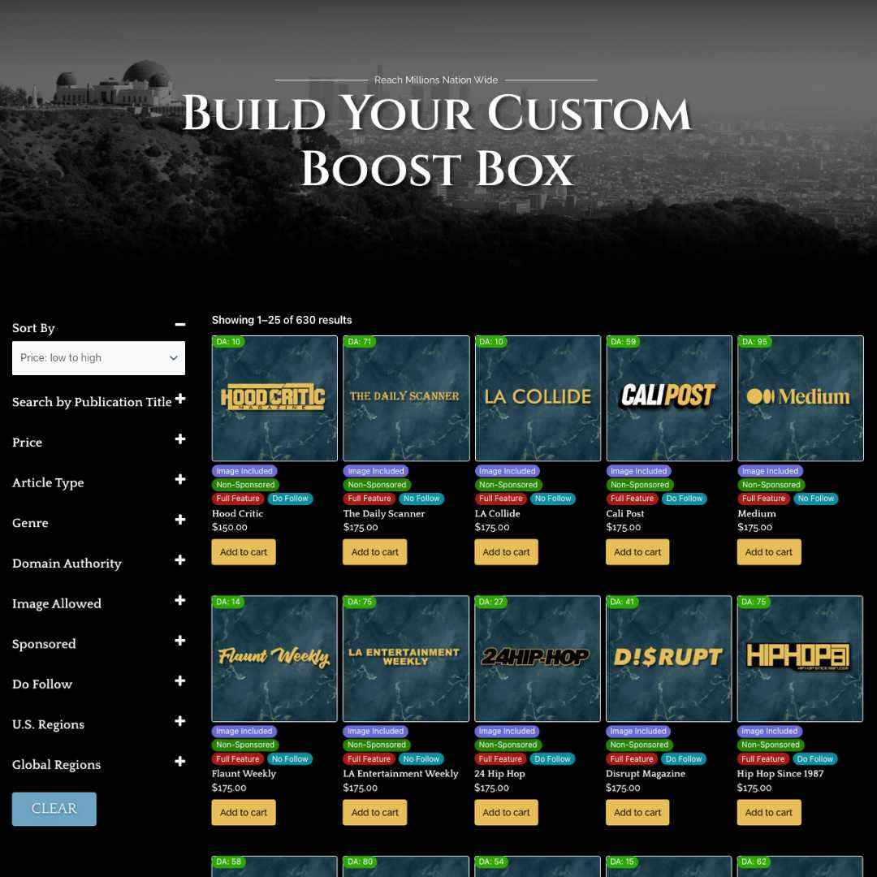  
  
In the articles themselves, clients are provided both do-follow and no-follow backlinks, depending on what is most effective and appropriate. While do-follow links offer direct SEO benefits, no-follow links still contribute significantly to improving search rankings. With Boost Box, clients can rest assured that their PR efforts will yield tangible results, regardless of the backlink type.  
  
To help build trust, Boost Box is backed by the "Boost Box Guarantee," which ensures clients receive a full refund if, for any reason, an article fails to get published. This unwavering commitment to excellence underscores Boost Box's dedication to delivering results.  
  
The launch of Boost Box points to a new era in the PR industry, empowering businesses to unlock their true potential by securing placements in top-tier publications. With guaranteed results, long-lasting impact, and expertly crafted articles, Boost Box aims to become the top solution for brands seeking to attract ready-to-buy customers and rank higher on Google quickly and reliably.  
  
So far, the early response from clients has been passionate.  
  
In a five-star review, Chris S., from New York, said, "We have found using press releases to promote our brand was very hit or miss, with more misses than hits, to be honest. It's frustrating to pay for publishing and then see dozens of low-quality, uninteresting news sites that don't fit well with what we are doing. A friend suggested we explore Boost Box, after his project has used it successfully for the last few months, and this was exactly what we needed. The articles are amazing and help us not just with traffic but also with credibility. We totally recommend Boost Box! It is an important part of how we get out the word moving forward."  
  
For more information, be sure to visit [www.boostboxpr.com](http://www.boostboxpr.com/).

