Simple Traffic Delivers High Quality, Targeted Traffic for Increased Sales and Engagement

SimpleTraffic provides targeted traffic to help increase sales and engagement for your business. Their traffic is 100% real, has the potential to convert into sales, leads, and signups, and is visible in Google Analytics. Improve your website's success and boost your search engine ranking with SimpleTraffic's authentic traffic solution.

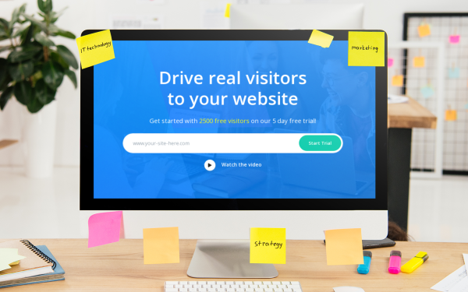

SimpleTraffic is proud to launch its new website traffic platform, designed to help businesses and individuals drive high-quality traffic to their online properties. With a focus on delivering targeted, engaged visitors who have the potential to convert into sales, leads, and signups, SimpleTraffic's platform is revolutionizing the way businesses drive traffic to their websites.

"We are excited to be able to offer a product that helps our customers increase the visibility of their websites and generate more business," says John Doe, CEO of SimpleTraffic. "Our platform is easy to use and provides measurable results, making it the perfect solution for anyone looking to boost their website traffic and drive growth."

Unlike bots or fake visitors, the 100% real traffic delivered by SimpleTraffic can navigate websites and click on links, providing a more authentic user experience. This traffic is also visible in Google Analytics, allowing businesses to track their success and improve their position on Google and other search engines.

SimpleTraffic's platform utilizes advanced algorithms and data analysis to identify the most effective channels for driving traffic to specific websites, delivering results that consistently surpass industry standards. With a focus on helping businesses achieve their online traffic goals, SimpleTraffic's state-of-the-art platform is a valuable tool for any business looking to increase website traffic and drive growth.

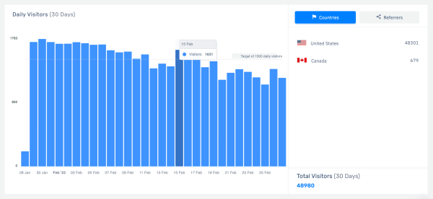

In addition to its website traffic services, SimpleTraffic also offers a range of tools and resources to help businesses and individuals improve the quality of their traffic. From comprehensive keyword research and competitor analysis to professional content creation and social media marketing strategies, SimpleTraffic has everything you need to enhance the effectiveness of your online marketing efforts. Our team is dedicated to helping you optimize your online presence and drive traffic to your website.

"At SimpleTraffic, we are committed to delivering the highest quality traffic to our customers and helping them succeed online," says Doe. "Our platform is designed to deliver targeted, engaged visitors who have the potential to convert into sales, leads, and signups. We can use advanced algorithms and data analysis to identify the most effective channels for driving traffic to specific websites and deliver results that consistently surpass industry standards."

[ EMBED YOUTUBE VIDEO: https://www.youtube.com/watch?v=HLoB-dLMUwY ]

In addition to its website traffic services, SimpleTraffic also offers a range of tools and resources to help businesses and individuals improve the quality of their traffic. From keyword research and competitor analysis to content creation and social media marketing, SimpleTraffic has everything you need to increase the effectiveness of your online marketing efforts. Our team is dedicated to helping you optimize your online presence and drive traffic to your website.

To learn more about SimpleTraffic and its website traffic services, visit https://www.simpletraffic.co/

Contact Details:
Business Name: Simple Traffic
Contact Name: Jessica McCloud
Email: hello@simpletraffic.co
Country: United States
Website: https://www.simpletraffic.co

