How Comfyland is the best brand for furniture

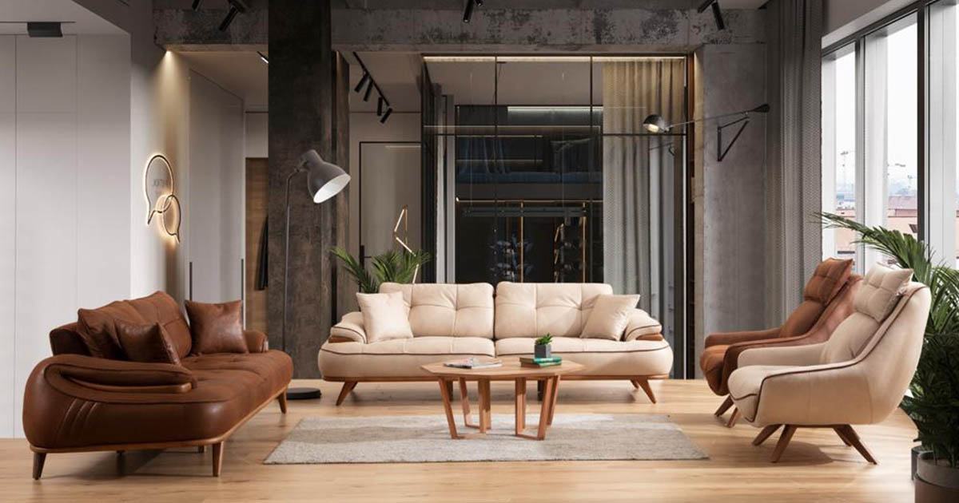
(London, UK) Comfyland, a contemporary furniture brand, launches a new design that allows consumers to express their personal tastes and lifestyles.
Comfyland has revealed its lineup of special discounts offering on the selection of bedroom, living room, and dining room furniture.
With 40 years of experience in the furniture industry and multiple showrooms around the Middle East, France, and Africa, Comfyland brings furniture at the lowest prices. Comfyland is a household furniture manufacturer, distributor, and retailer of decorative and functional household equipment.
Comfyland is committed to providing quality furniture with a selection of top-selling bedrooms, occasional furniture, and upholstery choices available for immediate shipment.
As a renowned furniture brand in the UK, Middle East, France, and Africa, Comfyland wants to be a leader in the furniture business and provide quality furniture selection, sophisticated design, and competitive pricing. They strive to make unique pieces using the best quality materials to enhance lifestyle and culture through unique furnishings.
Each category of furniture includes master and youth bedrooms, entertainment, seating, upholstery, dining, and more. They guarantee consistency, quality, and availability. Comfyland feels proud of its dedication to exceptional craftsmanship, such as 100% wooden furniture.
Comfyland understands what their customer value and ensures that quality control is maintained throughout the manufacturing process, so products withstand the test of time.
Comfyland has created a wide range of furniture that is suitable for the UK, Middle East, Africa, and France lifestyles. Each product is designed to meet the requirements of customers. The furniture is ergonomically designed to offer maximum comfort. The brand's success has been influenced by factors such as innovative value-added services, an efficient shopping experience, quality products, and high product quality.
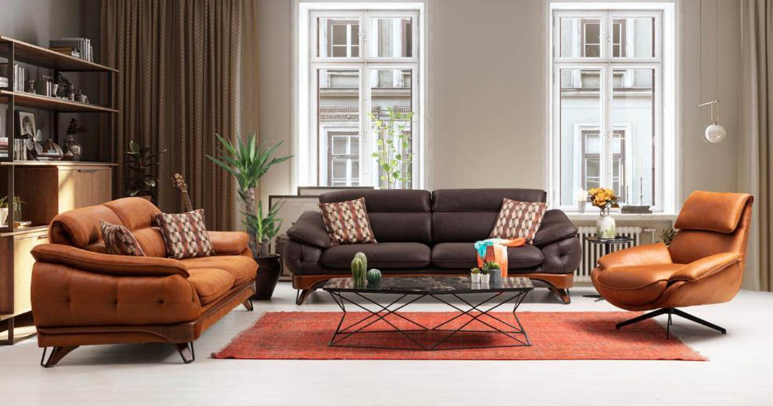
Being a global leader in furniture manufacturing, Comfyland will be the best-known furniture brand in the UK and offer a wide range of furniture, including sofa sets, dining, living, and outdoor furniture.
With thousands of satisfied customers, Comfyland is a pioneer in modern furniture retail. Comfyland furniture collection includes a variety of international and indigenous furniture designs. It has been the most trusted furniture retailer in the UK, Middle East, Africa, and France for the past year and has revolutionized customers' lives through its exclusive furniture range.
Comfyland has the dream to make the industry a dominant force through its outstanding reputation for high-quality furniture and unmatched customer service.

