Comedian Jodell "Joe Show" Lewis Captivates Audience With Style
Stand-up Comedian Joe Show is putting laughter on everyone’s faces with his unique brand of comedy that pays homage to both his NYC and his Caribbean background.
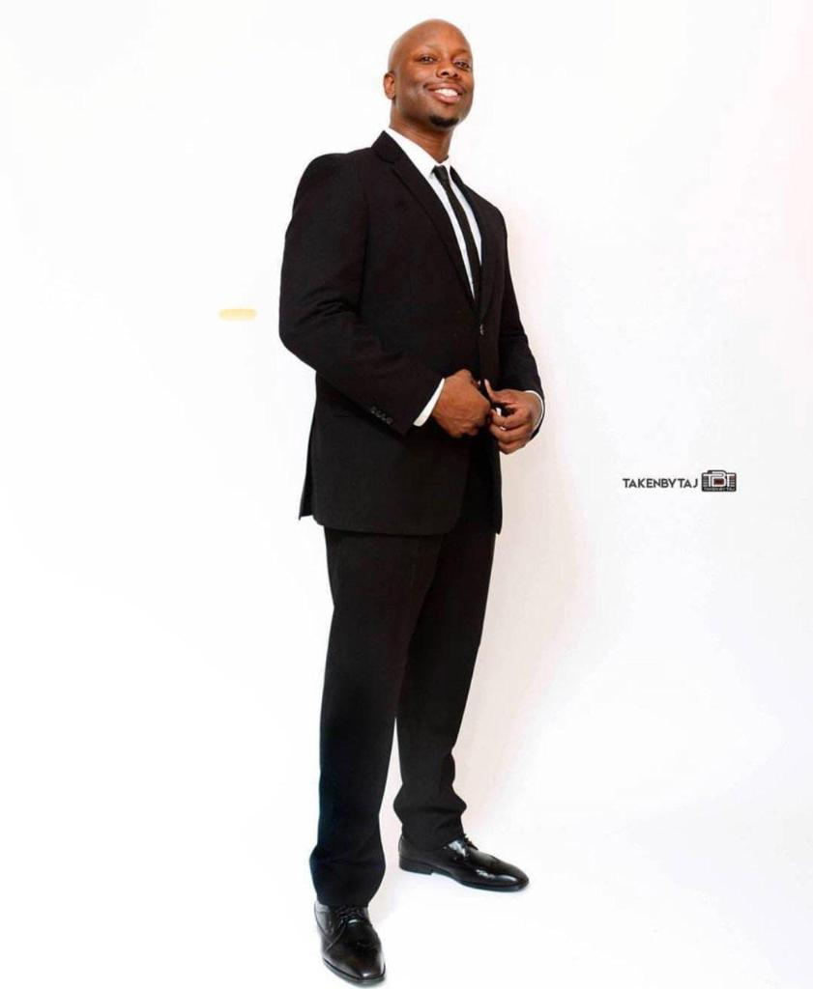
Humans have always enjoyed a good laugh. Since the dawning of the ages, laughter has been one of the earliest methods through which humans communicated with each other. In fact, scientists have traced the evolution of laughter to about 10 to 16 million years ago when the first humans appeared on the scene. Laughter is beloved for its immense psychological, physical, and emotional benefits. It is for this reason that jokesters were so revered during the times kings and queens reigned over the terrain. It is also why comedians are still an integral part of today’s society.
For comedian Jodell “Joe Show” Lewis, making people laugh is his high calling and one he intends to fulfill to the best of his ability. Fortunately as the world struggles with depression, inflation, conflicts, strife, and other numerous societal ills, Joe Show’s skills has never been more needed than now. Through his funny jokes, comic reliefs, and skits, the comedian is serving up joy, hope, and optimism to a wearied population.
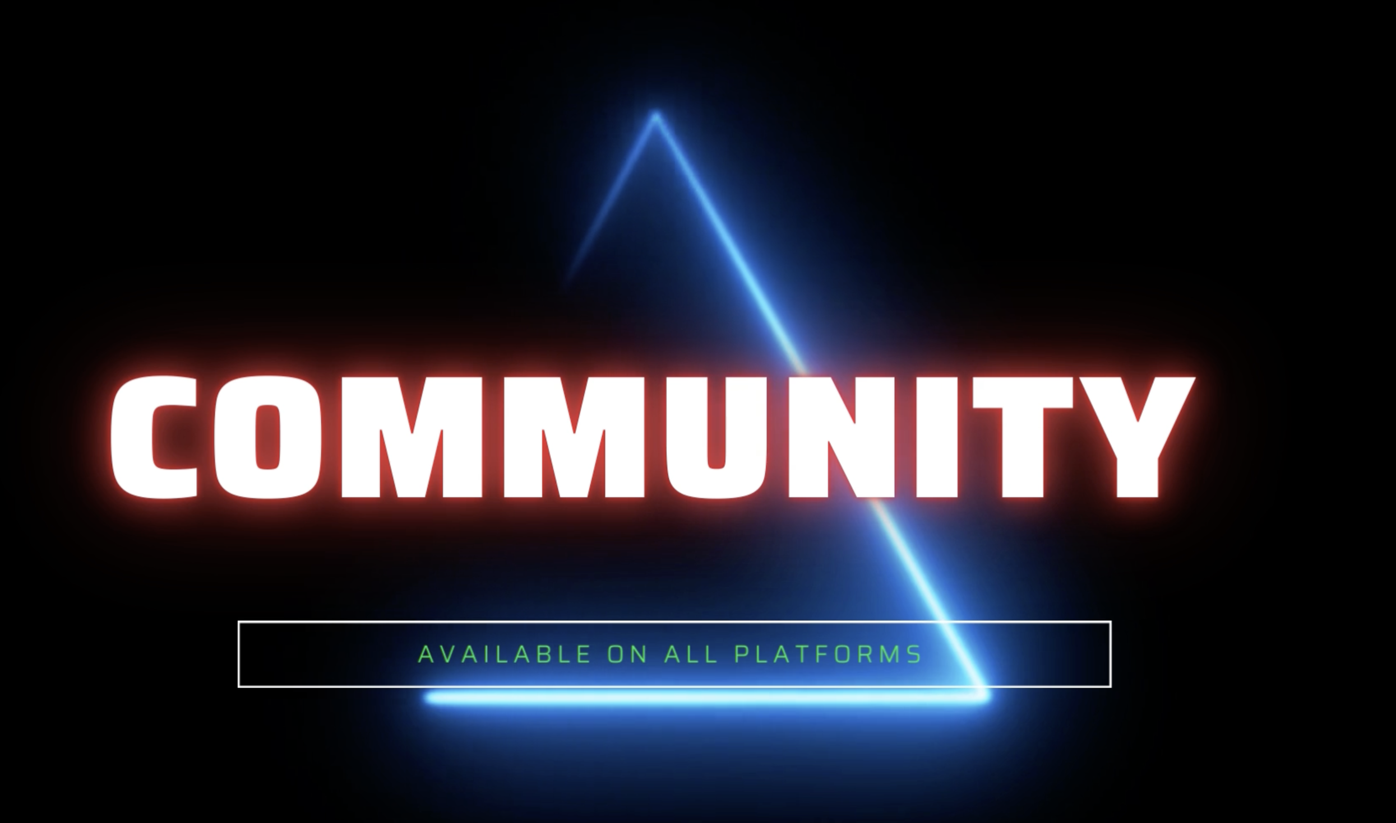
Joe Show has been performing his unique style of hilarious comedy for about 12 years running and he shows no sign of stopping anytime soon. The comedian who originally hails from Grenada but calls Brooklyn his home was given his stage name by the many teens he mentored at the group home he worked at before becoming a full time comedian. Thus, as an ode to his Caribbean background and spicy personality, Joe Show started Jerk Comedy Entertainment to capitalize on his blossoming career.
His versatile comedy blends stories of dating in New York City with tales of being raised in a Caribbean household all the while dealing with anxiety and awkwardness. This unique style of comedy has been met with positive reception by all types of audience. As a result, Joe Show has been invited to perform all over the country. He has also made several appearances at noted comedy clubs such as the improvComedy club, Comedy Union, Laugh house, The Jokers comedy club, Stand UP NY, and the Apollo.
Jodell “Joe Show” Lewis’ talents is a man of many talents who is not restricted to comedy, however. The notable comedian has been featured as an actor on the network series NYPD Blue City. He is also part of the cast of actors in the award-winning independent short film Behavior. Joe has even tried his hand backstage and is the co-creator of Against Community Guidelines. What’s more, Joe Show has further carved out a name for himself in the social media world as an influencer and content creator with a following of 27k.
Joe Show currently produces his own weekly comedy night in NYC which has been running for eight years straight. To know more about this program and keep up with the comedian, please follow him on Instagram.
Contact Details:
Business Name: OmnipresentLive TV
Bookings Contact : LA Wright
Contact Email: opmstreams@gmail.com
Contact Number: 9802898806
Address: 153-30 89th Ave Jam. NY 11432
Country: United States
Website: www.opmstreams.live

